

Create a web form that accepts a user's name and age. EXP.NO: 4 Write a Servlet to process the form data and display it
back on the browser.

AIM:

To create a simple web application that includes a form to accept a user's name and age, and then use a Servlet to process the submitted data. The Servlet will retrieve the form data, process it, and display the values back on the browser.

ALGORITHM:

1. Input:

• The user fills out a web form with their name and age and submits it.

2. Form Handling and Servlet Processing:

1. Create the Web Form:

o Create an HTML form with two input fields: one for the user's name and one for the user's age.

o Add a submit button to the form.

o Set the form's action attribute to the URL of the Servlet and the method to POST (or GET).

2. Create the Servlet Class:

o Write a Servlet that processes the form data submitted by the user.

o The Servlet will override the doPost() (or doGet() depending on the form method) to handle form submissions.

o The Servlet will retrieve the name and age parameters from the request object using request.getParameter("name") and request.getParameter("age").

3. Process the Data in the Servlet:

o Extract the name and age values submitted from the form.

o Validate the input (e.g., check if the age is a valid number).

o Prepare a response that will display the user's name and age back on the browser.

4. Send Response to the Browser:

o The Servlet will send a response to the browser containing a message like:
▪ "Hello, [name]! You are [age] years old."

o The response will be displayed to the user in the browser.

5. Deploy the Servlet:

o Compile the Servlet and deploy it to a Servlet container (like Apache Tomcat).

o Ensure the web.xml file or Servlet annotations are used to map the Servlet to the URL defined in the form's action attribute.

6. Test the Application:

o Open the web browser, fill in the form with the name and age, and submit it.

o The Servlet will process the data and display the message back to the user in the browser.

HTML File ( index.html ):

<!DOCTYPE html>

<html>

<head>

<title>Weather Info Portal</title>

<style>

body {

margin: 0;

font-family: Arial, sans-serif;

background: linear-gradient(to right, #4facfe, #00f2fe);

color: white;

text-align: center;

}

.navbar {

background-color: #003366;

padding: 15px;

font-size: 20px;
font-weight: bold;

}

.container {

margin-top: 80px;

}

.card {

background: white;

color: black;

width: 350px;

margin: auto;

padding: 30px;

border-radius: 10px;

box-shadow: 0px 8px 20px rgba(0,0,0,0.3);

}

input {

width: 90%;

padding: 10px;

margin: 10px 0;

border-radius: 5px;

border: 1px solid gray;

}

button {

padding: 10px 20px;

background-color: #4facfe;

border: none;
color: white;

border-radius: 5px;

cursor: pointer;

}

button:hover {

background-color: #007acc;

}

footer {

margin-top: 100px;

padding: 10px;

background-color: #003366;

}

</style>

</head>

<body>

<div class="navbar">

🌦 Weather Information Portal

</div>

<div class="container">

<div class="card">

<h2>Enter Your Details</h2>

<form action="UserServlet" method="post">

<input type="text" name="username" placeholder="Enter Name" required><br>

<input type="number" name="age" placeholder="Enter Age" required><br>

<button type="submit">Check Weather</button>
</form>

</div>

</div>

<footer>

© 2026 Weather Portal | Designed by Kamalesh

</footer>

</body>

</html>

Java File ( UserServlet.java ) :

import java.io.*;

import javax.servlet.*;

import javax.servlet.http.*;

import javax.servlet.annotation.WebServlet;

@WebServlet("/UserServlet")

public class UserServlet extends HttpServlet {

protected void doPost(HttpServletRequest request, HttpServletResponse response)

throws ServletException, IOException {

response.setContentType("text/html");

PrintWriter out = response.getWriter();

String name = request.getParameter("username");

int age = Integer.parseInt(request.getParameter("age"));

String category;
if(age < 18)

category = "Young Explorer ";

else if(age < 40)

category = "Active Adult ";

else

category = "Wise Citizen ";

out.println("<html>");

out.println("<head>");

out.println("<title>Weather Result</title>");

out.println("<style>");

out.println("body{font-family:Arial;background:linear-gradient(to right,#43cea2,#185a9d);color:white;text-align:center;}");

out.println(".card{background:white;color:black;width:400px;margin:100px auto;padding:30px;border-radius:10px;box-shadow:0px 8px 20px rgba(0,0,0,0.3);}");

out.println("h2{color:#185a9d;}");

out.println("</style>");

out.println("</head>");

out.println("<body>");

out.println("<div class='card'>");

out.println("<h2>Weather Information Result</h2>");

out.println("<p><b>Name:</b> " + name + "</p>");

out.println("<p><b>Age:</b> " + age + "</p>");

out.println("<p><b>Category:</b> " + category + "</p>");

out.println("<hr>");

out.println("<h3> Chennai Weather</h3>");

out.println("<p>🌡 Temperature: 32°C</p>");

out.println("<p>☀ Condition: Sunny</p>");

out.println("</div>");
out.println("</body>");

out.println("</html>");

}

}

File ( web.xml) :

<web-app> <servlet>
<servlet-name>UserServlet</servlet-name> <servlet-class>UserServlet</servlet-class>
</servlet>

<servlet-mapping>
<servlet-name>UserServlet</servlet-name> <url-pattern>/UserServlet</url-pattern>
</servlet-mapping> </web-app>

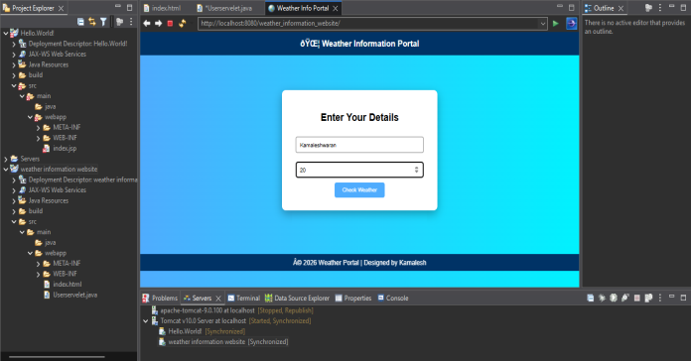
OUTPUT:

RESULT:

Thus A Servlet was created to process the HTML form data and display it back on the browser.

